TASK 5:

.model small
.stack 64
.data

.code

MAIN PROC FAR

MOV AX, 0
MOV DS, AX

MOV SI, 0X2000 ; Initial Address

;Initializing Values at the addresses
MOV BYTE PTR [SI], 0X45
ADD SI, 2

MOV BYTE PTR [SI], 0X67
ADD SI, 2

MOV BYTE PTR [SI], 0X89
ADD SI, 2

MOV BYTE PTR [SI], 0XAB
ADD SI, 2

MOV BYTE PTR [SI], 0XCD
ADD SI, 2

MOV BYTE PTR [SI], 0XEF
ADD SI, 2

; Resetting address
MOV SI, 0X2000

; Adding 1st THREE BYTES in AL
ADD AX, [SI]
ADD SI, 2

ADD AX, [SI]
ADD SI, 2

ADD AX, [SI]
ADD SI, 2

; Adding LAST THREE BYTES in AL
ADD BX, [SI]
ADD SI, 2

ADD BX, [SI]
ADD SI, 2

ADD BX, [SI]
ADD SI, 2

; ADDING AL & BL
ADD AX, BX
MOV CX, AX

MOV AX, 0008H
MOV DS, AX
MOV BX, 0X3F5A

MOV [BX], CX

MOV AH, 4CH
INT 21H

MAIN ENDP

.exit

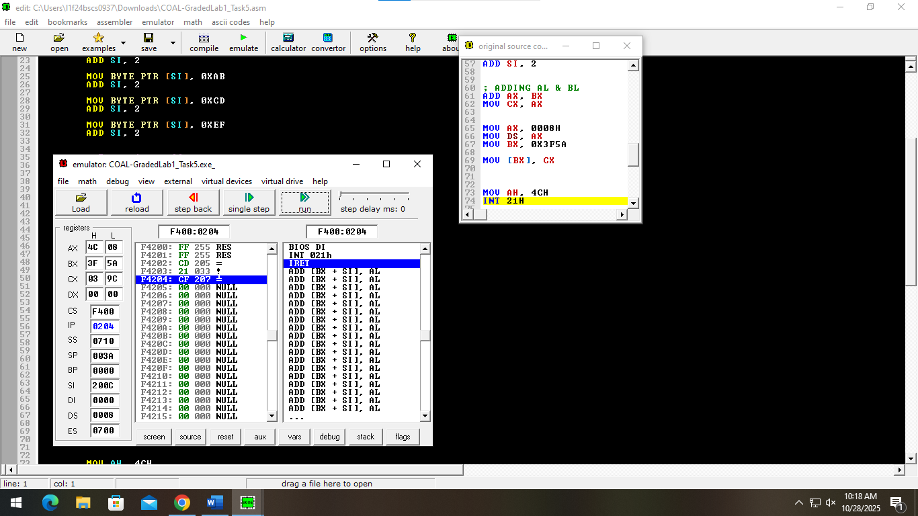

TASK 3:

.model small
.stack 64
.data

.code

MAIN PROC FAR

MOV AX, 0X1234
MOV BX, 0X5678
MOV CX, 0X9ABC
MOV DX, 0XDEF0

MOV CH, 0
MOV DH, 0

ADD CX, DX ; CL + DL

; FOR (AH + BH)
MOV DH, AH
MOV AH, 0
MOV DL, BH
MOV BH, 0

ADD DH, DL

ADD CX, AX
ADD CX, BX

MOV DL, DH
MOV DH, 0

SUB CX, DX

MOV AH, 4CH
INT 21H

MAIN ENDP

.exit

